**Verify below software’s available**

1. **SQL Server**
2. **Power BI Desktop**
3. **Import below databases** 
   1. **ADVENTUREWORKS**
   2. **AdventureWorksDW**

For this go to github

[https://github.com/JPOWER4/Power-BI](https://github.com/JPOWER4/Power-BI 1)

1. Download <https://github.com/JPOWER4/Power-BI/blob/master/Demofiles.zip>
   1. Unzip
   2. Copy Demofiles folder and paste it in c: drive
2. Download <https://jpower4mvp-my.sharepoint.com/:u:/g/personal/jenkinsns_jpower4mvp_onmicrosoft_com/EQUaPaEeli1FleKJcnJRdQEBiCbRzwwmBOeNSigDQOwGgQ?e=D2jOrR>
   1. Unzip
   2. Copy SetupFiles folder and paste it in c:drive
3. Go to c:\Demofiles\Mod
   1. Execute setup file – run as administrator

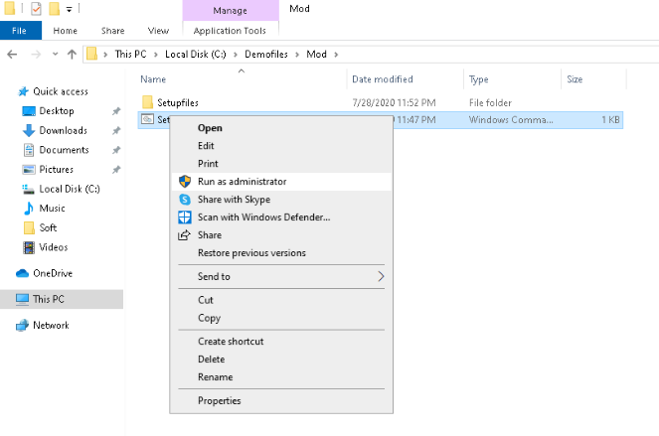

After completed, verify the databases available or not, refer below image

